**Install Docker on Linux**

We need a Linux instance. We will be creating a Linux instance in AWS Cloud.

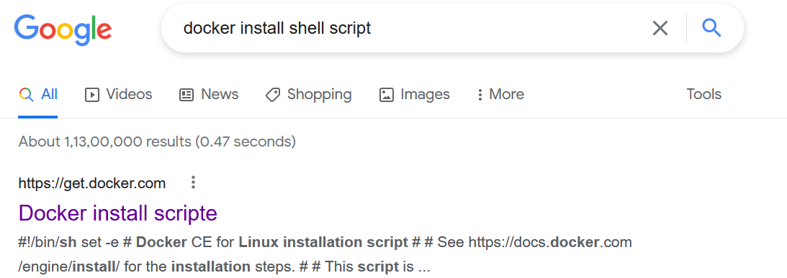

curl -fsSL https://get.docker.com -o get-docker.sh

sh get-docker.sh

sudo usermod -aG docker <username> #$USER

exit

# relogin

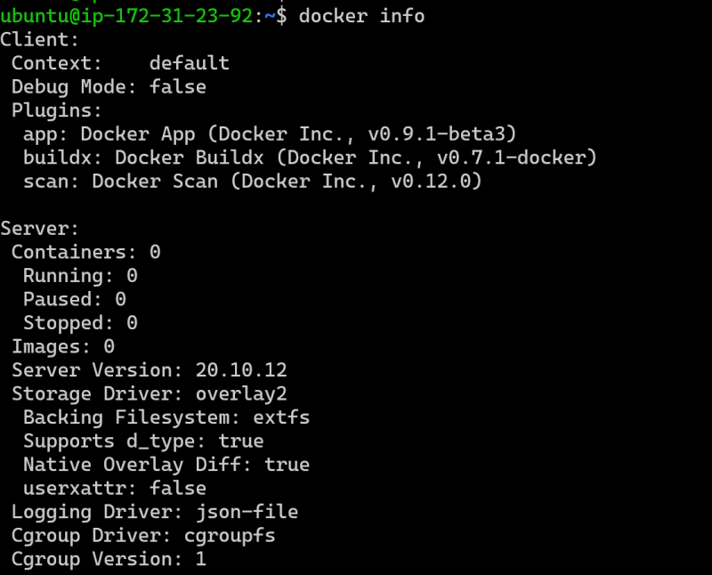

**Docker Image and Container Creation Basics**

* Let’s see the list of the images in the newly installed docker

docker image ls

* Downloading the image from registry is called as pull
* The image name has two components <name-of-image>:<tag>
* name of the image represents application
* tag represents the version
* If you dont pass the tag, docker will consider tag as latest so
* if you have written image name as httpd == httpd:latest
* Now lets pull the jenkins/jenkins image

docker image pull jenkins/jenkins

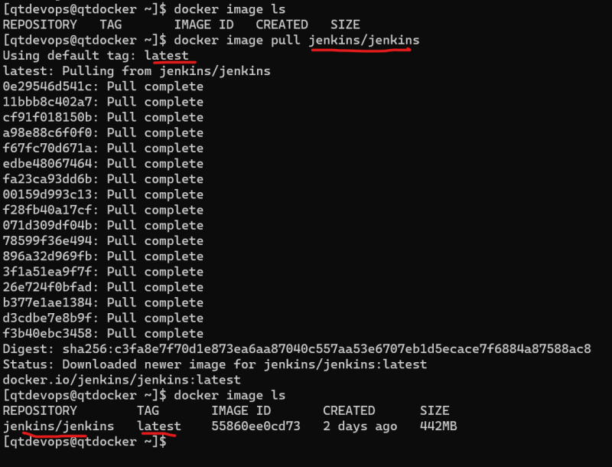

Now let’s look at the tags of jenkins/Jenkins(<https://hub.docker.com/r/jenkins/jenkins/tags>)   
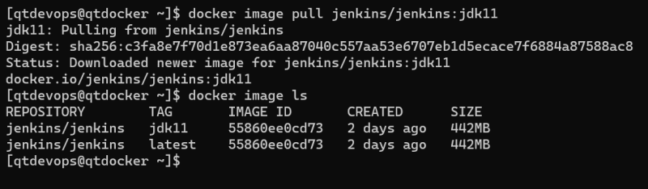

Every image in the registry will have unique image id.  
Two different images have the same image id imply that they are same images with different names.  
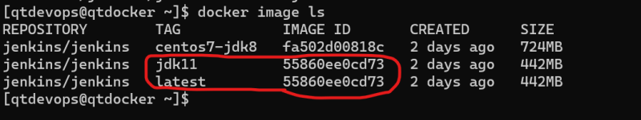

Let’s create a jenkins container docker container run -d <image>:<tag> docker container run -d jenkins/Jenkins docker container ls

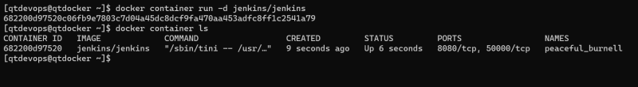

To access the application inside the docker we have to do port forwarding docker container run -d -p <hostport>:<containerport> <imageid>:<tag>  
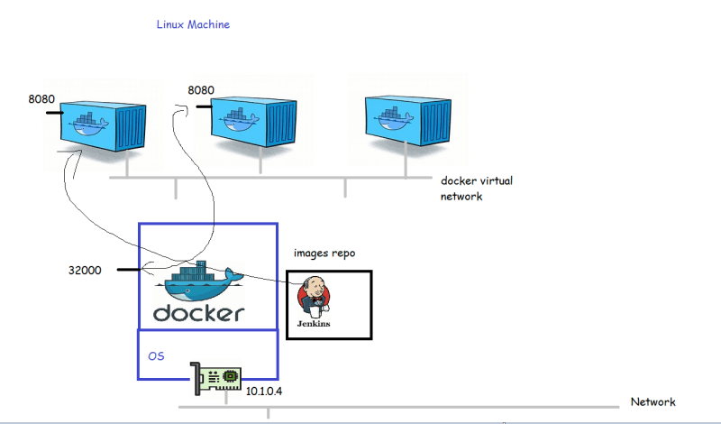

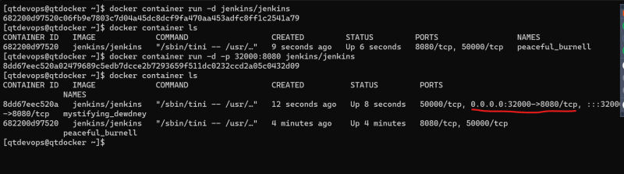

Let’s try to create an apache continer  
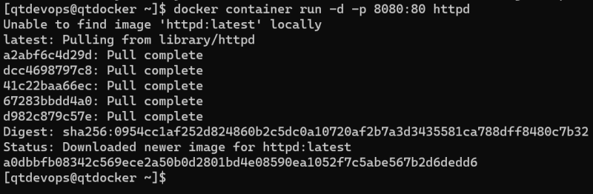  
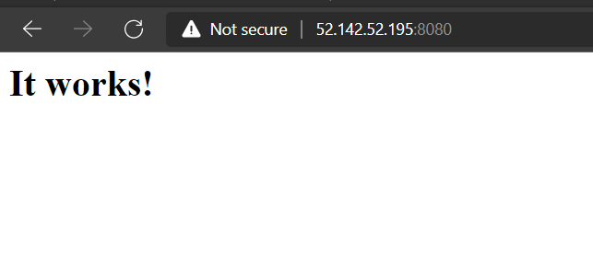  
Overview of port forwarding  
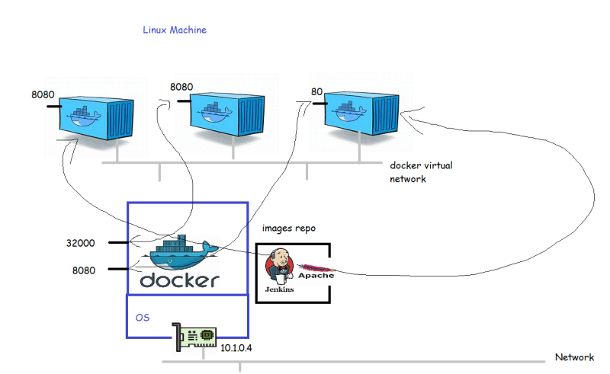Docker can map the container port to dynamic port on the Docker Host (Linux VM) docker container run -d -P <imageid>:<tag>